Examination, 2017

Question/Answer Booklet

ECONOMICS Units 1 & 2

Student Number: in figures

In words:

Student Name: __________________________________________

Time allowed for this paper

Reading time before commencing work: ten minutes
Working time for paper: three ( 3 ) hours

Materials required/recommended for this paper
To be provided by the candidate
Standard items: pens (blue/black preferred), pencils (including coloured), sharpener,
correction fluid/tape, eraser, ruler, highlighters
Special items: non-programmable calculators approved for use in the WACE examinations

Important note to candidates
No other items may be taken into the examination room. It is your responsibility to ensure that you do not have any unauthorised notes or other items of a non-personal nature in the examination room. If you have any unauthorised material with you, hand it to the supervisor before reading any further.

Structure of this paper

Section | Number of questions available | Number of questions to be answered | Suggested working time (minutes) | Marks available
Section One:  Multiple-choice | 24 | 24 | 30 | 24
Section Two:  Data interpretation / Short response | 3 | 3 | 70 | 36
Section Three:  Extended response | 4 | 2 | 80 | 40
 |  |  | Total: | 100

Instructions to candidates

1. Answer the questions according to the following instructions.

Section One: Answer all questions on the separate Multiple-choice Answer Sheet provided. For each question shade the box to indicate your answer. Use only a blue or black pen to shade the boxes. If you make a mistake, place a cross through that square, then shade your new answer. Do not erase or use correction fluid/tape. Marks will not be deducted for incorrect answers. No marks will be given if more than one answer is completed for any question.

Section Two: Write answers in this Question/Answer booklet. Spare pages are included at the end of the booklet. They can be used as additional space if required to continue an answer. If you need to use the space to continue an answer, indicate in the original answer space where the answer is continued, i.e. give the page number. Fill in the number of the question(s) you are continuing at the top of the page.

Section Three: Write answers in this Question/Answer booklet. Pages are included at the end of this booklet for planning and writing your answer.
- Planning: If you use the spare pages for planning, indicate this clearly at the top of the page.
- Answering the question: In the pages provided indicate clearly the number of the question you are answering.
2. You must be careful to confine your responses to the specific questions asked and to follow any instructions that are specific to a particular question.

Section One: Multiple Choice (24 Marks)

This section has 24 questions. Answer all questions on the separate Multiple-choice Sheet.

For each question shade the box to indicate your answer. Use only a blue or black pen to shade the boxes. If you make a mistake, place a cross through that square, then shade your new answer. Do not erase or use correction fluid/tape. Marks will not be deducted for incorrect answers. No marks will be given if more than one answer is completed for any question.

Suggested working time: 30 minutes.
________________________________________________________________________

1 | Two brands of water, ‘Natural Water’ and ‘Mountain Water’ are close substitutes. If the price of Mountain Water decrease, this fall in price
 | a | shifts the demand curve for Natural water rightward
 | b | shifts the demand curve for Natural Water leftward
 | c | increases the price of Natural Water
 | d | decreases the demand for Mountain Water
2 | Suppose that milk producers expect that the price of milk is going to increase next month. This would cause
 | a | an increase in the demand for milk today
 | b | a decrease in the supply of milk today
 | c | an increase in the supply of milk today
 | d | the selling price of milk to rise today
3 | Suppose the equilibrium price of oranges is $2.00 per kg. If the actual price is above the equilibrium price, a
 | a | shortage exists and the price falls to restore equilibrium
 | b | shortage exists and the price rises to restore equilibrium
 | c | surplus exists and the price rises to restore equilibrium
 | d | surplus exists and the price falls to restore equilibrium
4 | A movie theatre raises ticket prices from $14 to $16 in order to raise revenues. The theatre’s management is assuming the absolute value of the price elasticity of demand for tickets is
 | a | less than 1
 | b | greater than 1
 | c | equal to 1
 | d | infinity

5 | A rise in the price of a product from $50 to $60 causes demand to fall from 800 to 760 units. The price elasticity of demand (Ped) coefficient is
 | a | 4.0
 | b | 0.5
 | c | 2
 | d | 0.2

Refer to the diagram below to answer the following question
6 | Which change could explain the shift of the supply curve for a product from S to S1 as shown in the diagram below?
 | 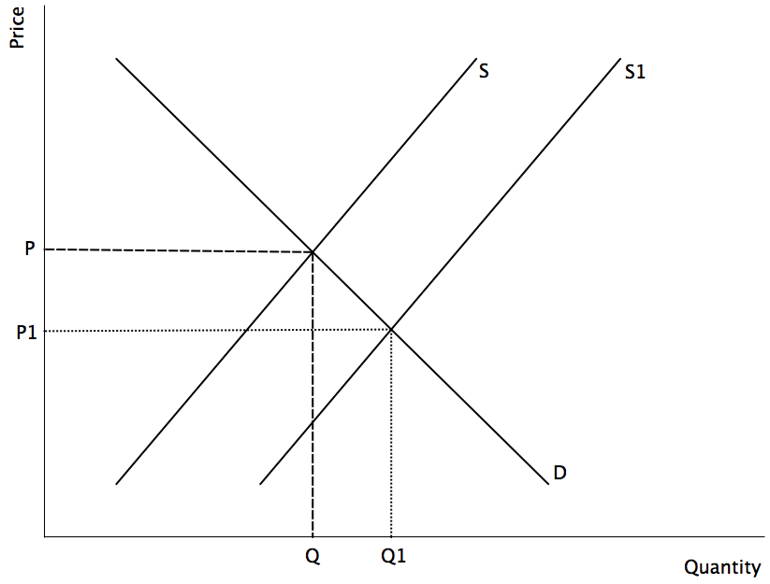
 | a | A rise in price from P1 to P
 | b | A rise in the quantity demanded from Q to Q1
 | c | A reduction in the cost of producing the product
 | d | The imposition of a tax on the product
7 | Melissa must always have cream in her coffee. For Melissa, the cross-price elasticity of demand for coffee and cream is
 | a | equal to 0
 | b | negative
 | c | positive
 | d | impossible to determine without more information

8 | Lorna owns an ice cream shop. It costs her $2 per cone to make 10 ice cream cones. If she sells 10 cones for $4 each, her producer surplus on the 10 cones is equal to
 | a | $2
 | b | $20
 | c | $10
 | d | $40
9 | Which of the following best describes the economic concept of ‘free-riding’?
 | a | Distributing the benefit of the good equally throughout society
 | b | Allowing all commuters to travel for free on public transport at the weekends
 | c | Consumers not paying for the benefits of consuming a good
 | d | Not requiring the producer of a good to pay for the benefits associated with production of that good
10 | Government intervention in the market which results in a price ceiling below the market equilibrium price implies that
 | a | producer surplus will increase at the expense of eroded consumer surplus
 | b | deadweight loss will be zero as the total surplus is constant but is simply redistributed in favour of consumers
 | c | deadweight loss is reduced by the price ceiling, and sellers over-produce in response to a price ceiling below equilibrium
 | d | other things equal, consumer surplus is likely to increase at the expense of eroded producer surplus.
11 | If the total leakage of income exceeds the total injection of income
 | a | the economy will be in a state of disequilibrium
 | b | there will be a downward adjustment in government expenditure
 | c | employment opportunities will improve
 | d | the economy will remain in its present state
12 | Which of the following government policies could reduce income inequality in an economy?
 | a | Lowering welfare payments and decreasing taxes.
 | b | Increasing welfare payments and decreasing the tax-free threshold
 | c | Increasing the age pension
 | d | Increasing the cost of job retraining programs

13 | Which of the following factors could cause a rise in structural unemployment?
 | a | A fall in aggregate demand in the economy
 | b | A rise in the number of workers between jobs
 | c | A lack of full time rather than part time work
 | d | A change in technology and production
14 | In a closed economy, if C=$400m, G=$60m, T=$40m, S=$110m and I=$100m, then it is likely that
 | a | income earned in the next period will fall
 | b | income earned in the next period will rise
 | c | interest rates will rise since consumption is less than income
 | d | the government budget will be in surplus
15 | Given the following figures, what is the balance on the Current Account?
 | Balance of Payments |  | ($ bn)
 | Net goods |  | 12
 | Net services |  | -3
 | Portfolio Investment |  | 15
 | Direct Investment |  | 3
 | Capital & Financial Account |  | 24
 | a | $ 24 Billion
 | b | - $ 9 Billion
 | c | $ 9 Billion
 | d | - $ 24 Billion
16 | The economy is in a recession and the housing market is in a slump. As a result of this, a real estate firm lays off half of its real estate agents. This is an example of
 | a | frictional unemployment
 | b | structural unemployment
 | c | seasonal unemployment
 | d | cyclical unemployment

17 | During 2016-17, the Australian economy was growing
 | a | above its long-term average and unemployment was below the natural rate
 | b | above its long-term average and unemployment was above the natural rate
 | c | below its long-term average and unemployment was above the natural rate
 | d | below its long-term average and unemployment was below the natural rate

18 | Australia’s three most important trading partners are
 | a | China, Japan and South Korea
 | b | China, United States and Japan
 | c | China, New Zealand and Japan
 | d | China, United States and United Kingdom
19 | Which of the following would be most to economists trying to predict future trends?
 | a | Rate of change of Gross Domestic Product
 | b | Consumer Price Index
 | c | Trade Weighted Index
 | d | Business Sentiment Index
20 | The production of inventories is considered part of investment in economics because
 | a | they may increase in value over time
 | b | they are an injection into the circular flow
 | c | they function as an excellent store of value
 | d | they will be sold at some future date

21 | If a businessman in London buys shares in an Australian company, this would appear as
 | a | a credit in the current account of Australia’s Balance of Payments
 | b | a debit in the current account of Australia’s Balance of Payments
 | c | a credit in the capital and financial account of Australia’s Balance of Payments
 | d | a debit in the capital and financial account of Australia’s Balance of Payments.
22 | Which of the following is an example of a regressive tax?
 | a | The GST
 | b | Personal Income Tax
 | c | Land Tax
 | d | Company Tax

23 | The largest component of Federal Government expenditure is
 | a | Defense
 | b | Health
 | c | Education
 | d | Social Security and Welfare

24 | The main reason for Australia’s Current Account Deficit is
 | a | the fall in commodity prices
 | b | the lack of an international shipping line
 | c | the increase in the number of Australians travelling abroad as tourists
 | d | the gap between savings and investment

__________________________________________________________________

End of Section 1

Section Two: Data interpretation/Short response (36 Marks)
This section contains three (3) questions. Answer all questions. Write your answers in the spaces provided.

Spare pages are included at the end of this booklet. They can be used as additional space if required to continue an answer. If you need to use the space to continue an answer, indicate in the original answer space where the answer is continued, i.e. give the page number. Fill in the number of the question(s) that you are continuing to answer at the top of the page.

Suggested working time: 70 minutes.
_________________________________________________________________________

Question 25 (12 marks)

Australia’s ‘shocker’ retail spending figures raise growth concerns
Date: Thursday 5 October 2017
Source: The Guardian

Australian retail trade dropped 0.6% in August, the worst monthly performance in more than four years, raising concerns among retailers as the Christmas period approaches.

Retail spending growth declined for the second month in a row in August and risks putting a dampener on overall economic growth for the September quarter.

It included a 1.3% fall in café, restaurant and takeaway food spending.

Commonwealth Bank economist Gareth Aird said that “It’s not surprising to see such weak retail trade outcomes given household income growth is so soft. But two consecutive monthly falls look at odds with the recent strength in the labour market,” he said.

The executive director of the Australian Retailers Association, Russell Zimmerman, blamed increased energy costs and higher tax burdens for the result and called for government action to lift confidence.

a. | i | What happened to total retail sales in August this year? | 1 mark

 | ii | Could the majority of the change in retail sales be classified as discretionary or non-discretionary consumption? | 1 mark

 | iii | Explain what Gareth Aird sees as being the major reason for the change in retail trade figures. | 1 mark

b. | Describe the type of action that Russell Zimmermann would like the government to take. Include any appropriate diagrams. | 4 marks

c. | Explain other actions the government could take to stimulate retail spending. | 5 marks

Question 26 (12 marks)

Jobless rate falls to 5.5 per cent

The fall in the jobless rate spells good news for the government or does it?

A surge in full-time employment over the past five months has raised optimism about the economy’s health, but is that positivity misplaced?

Analysts are divided – some see Australia’s struggling economy finally turning a corner, others point to near-record underemployment that is severely restricting wage growth.

Labour force figures revealed the unemployment rate for May fell to 5.5 per cent, down from 5.7 per cent in April, but still above the natural rate. The improved result was supported by a steady rise in the participation rate since the start of the year.

However, such apparent strength in the employment market has failed to lift the mood of consumers, concerned about job security and weak wages growth. A shift towards part-time staff by employers has also left many workers seeking additional employment. The underemployment rate – where an employee works fewer hours than desired – has increased over the past few years reaching a record high.
(Source: ABC News)

a. | How is the unemployment rate calculated? Calculate the unemployment rate if there were 16 million workers employed and 1 million unemployed. | 2 marks

b. | Explain why the participation rate would normally rise when the unemployment rate falls. | 2 marks

c. | What unemployment rate is considered to be the natural rate of unemployment for Australia? What types of unemployment are included in the natural rate? | 2 marks

d. | What is an underemployed worker? Why has Australia’s underemployment rate been rising? | 3 marks

e. | If the unemployment rate has been falling, why are consumers still pessimistic? | 3 marks

This page has been left blank

Question 27 (12 marks)

Cheese prices rise by up to 30%

“The price of cheese has surged by up to 30% in some cases thanks to rising dairy costs and increasing demand in Europe.

Purchasing company Beacon said that the increases were attributable for an increased European appetite for young dairy products such as butter and mozzarella.

Meanwhile, the price of milk is also hovering at around 27p per litre, an increase of 35% on the same period last year, as supply dwindled to their lowest level since May 2017.”

Source: https://www.thecaterer.com/articles/506326/cheese-prices-rise-by-up-to-30

a. | With reference to the excerpt, state why the price of milk has increased by 35%. | 1 mark

b. | Using evidence from the excerpt, describe the relationship between cheese and young dairy products. | 2 marks

c. | Using an appropriate diagram, illustrate and describe why young dairy prices have increased. |  | 5 marks

d. | Describe the relationship between cheese and milk | 4 marks

End of Section 2
Section Three: Extended response (40 Marks)

This section contains four (4) questions. Answer two (2) questions.

Pages are included at the end of this booklet for planning and writing your answer.
- Planning: If you use the spare pages for planning, indicate this clearly at the top of the page.
- Answering the question: In the pages provided indicate clearly the number of the question you are answering.
Suggested working time: 80 minutes.
________________________________________________________________________

Question 28 (20 marks)

- Explain the concepts of Price Elasticity of Demand (Ped) and Income
Elasticity of Demand (Yed). Give examples of each. (6 marks)

- The Australian Government introduces a tax of 15% on Samsung laptops
and Alcohol. Using diagrams, explain the impact on the demand for each
good due to the imposition of the tax. (14 marks)

Question 29 (20 marks)

- Identify and describe the components of Aggregate Expenditure (8 marks)

- Describe the factors affecting Consumption and Investment (12 marks)

Question 30 (20 marks)

- Using examples, illustrate and explain a positive consumption
externality and a negative production externality. (10 marks)

- Using models, explain how the government can internalise the externalities
in part (a) to raise market efficiency. (10 marks)

Question 31 (20 marks)

- Outline the five main economic objectives of the Australian government. (10 marks)

- Describe the phases of the business cycle in relation to the Government’s
economic objectives. (10 marks)
___________________________________________________________________________

End of Exam

